Standard Work Procedure

1. Read through file to find and highlight all relevant information.
2. Fill out checklist with information highlighted in folder. ( See below )

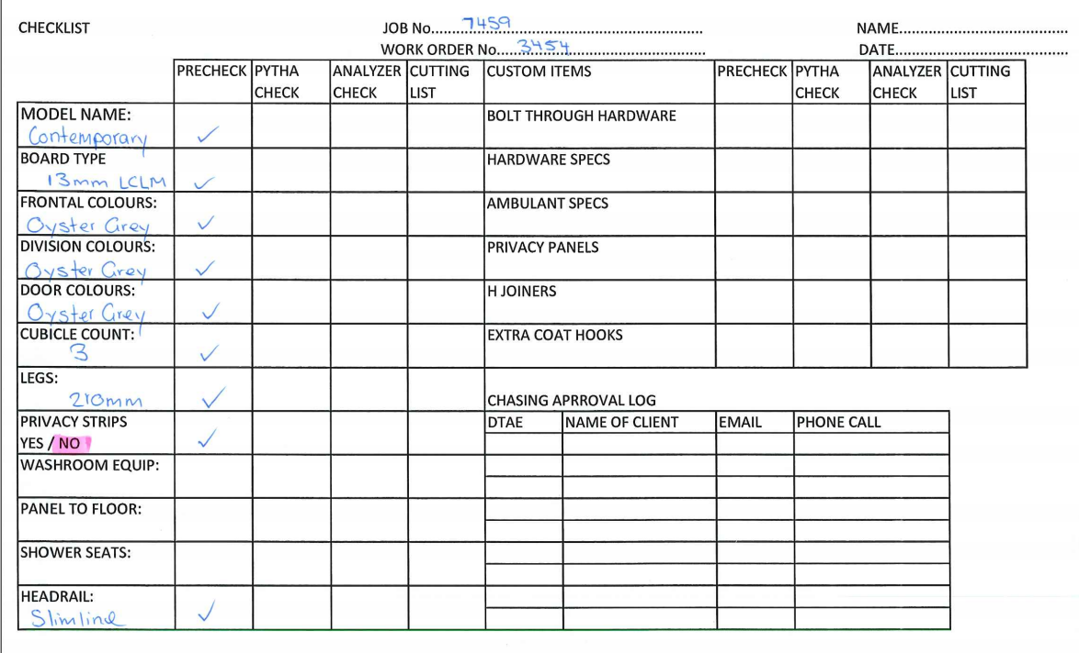

1. Complete shop drawings using the information deemed relevant from folder.
2. Fill out “Pytha Check” once you have completed drawings. If you have multiple drawing use a “Tick” per each drawings. 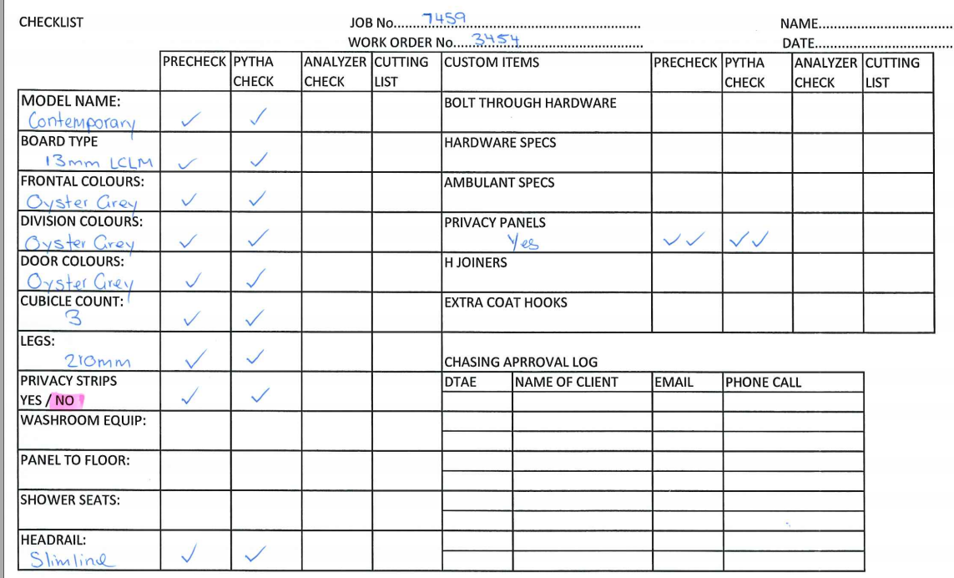
3. Open job in shop Pak and change status to seeking approval. Change project manager to your name.

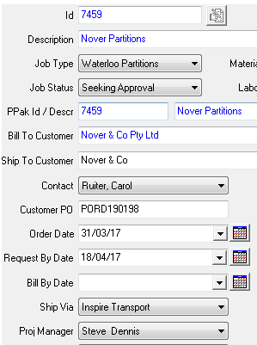

1. Complete Cross Check.



1. Send email seeking approval for shop drawings. 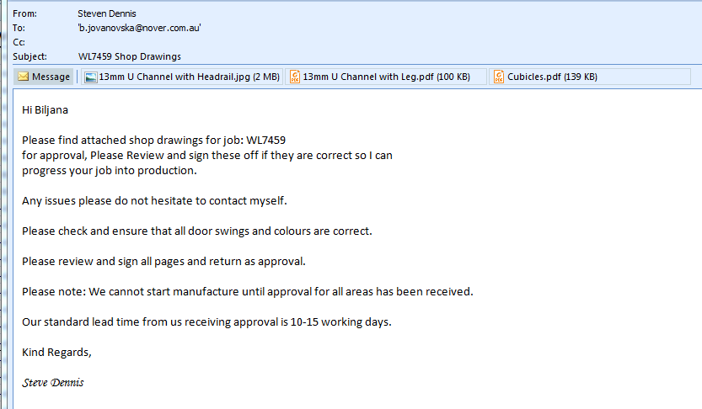
2. Fill out log on bottom of check list each time a email or phone is made over this job. 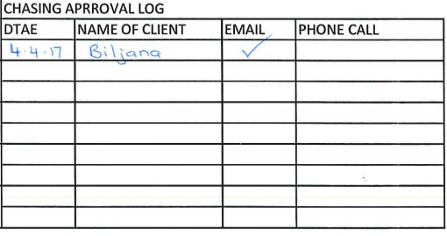
3. If you have not received approvals back after 24hrs a reminder email to be sent. Repeat step 8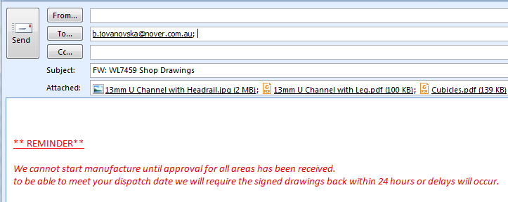
4. If approval has not been received after 48hrs a email stating a change in dispatch to now be sent. Also ring the contact person and inform them that a change in dispatch will now occur. Repeat step 8 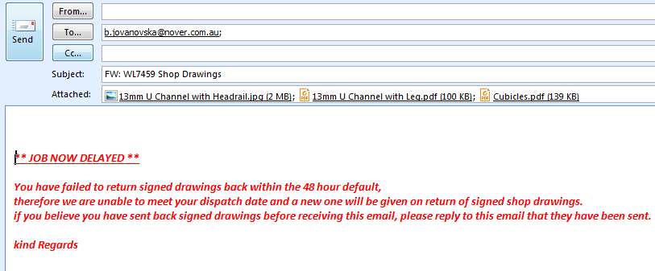

This is to be done everyday until approval is received.

1. The dispatch date ( Target Finish Date ) is to be changed everyday after the 48hr. 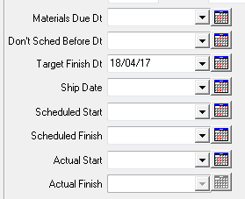
2. Once approval is received it is to be printed out. Make any changes that are requested. Create cut list and fill out check marked Analyzer whilst cut list is being created. 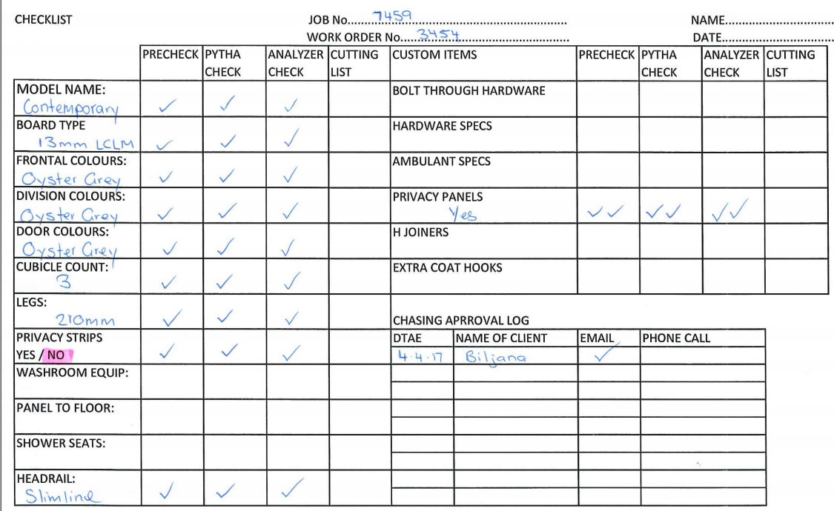
3. Use the printed approved shop drawings to make sure that all items are accounted for on the printed cutting list. Highlight every item on plan to make sure items are accounted for. 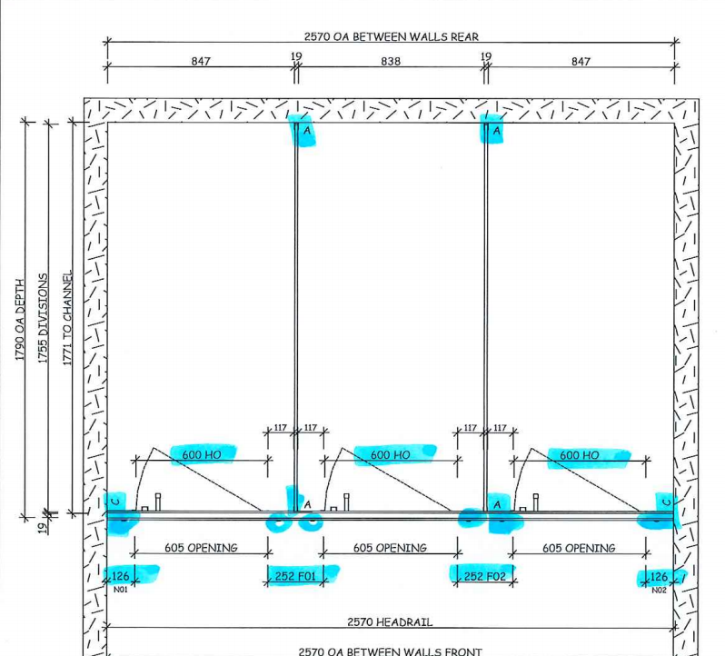
4. Change the status back from seeking approval to in progress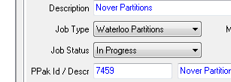

Also change in the wok order from engineering to purchasing. 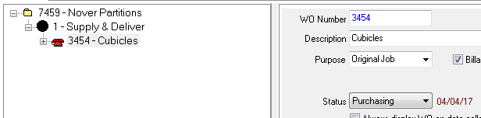

1. Clean out folder and take down to Sarah.